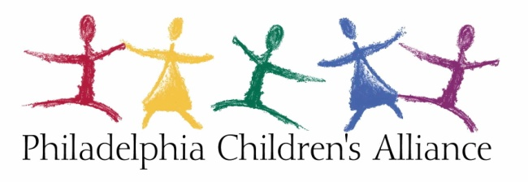

Development Coordinator (Full-Time, Exempt)

Mission: The Philadelphia Children's Alliance (PCA) is an independent non-profit organization whose mission is to lead a
coordinated response to achieve safety, healing, justice, and prevention for children and families impacted by sexual
abuse, exploitation, and violence. Using a multidisciplinary approach, we collaborate with our partners in child protection, law enforcement, and medical and mental health services to provide forensic interviews, victim support and counseling services at the Philadelphia Safety Collaborative, a co-located child-friendly facility. We are committed to using best practices and we promote this model locally and nationally.

Position Summary: Reporting to the Development and Communications Director, this position has diverse responsibilities that support the development and grant departments. This position is responsible for all aspects of the donor management software, including input, maintenance, and reporting. The Development Coordinator supports the myriad tasks around grant reports and the grant proposal process. This position helps to organize and coordinate activities around fundraising events and community education activities in a way that increases participation, engagement, and revenue from all of PCA’s audiences. The Development Coordinator will assist in gathering and coordinating social media and other communications content in order to sustain a high level of quality to increase the visibility, use, and impact of PCA’s website and digital marketing initiatives.

Key Responsibilities include the following:

- Accountable for managing the donor database Neon, to be utilized for gift and donor management, special events coordination, and foundation proposal/grant tracking (store, query and manage)
  - Prepare and mail thank you letters in a timely manner, produce reports, and keep files as required.
  - Process mailings for fundraising events and appeals
  - Responsible for correspondence and storage of all giving records, making them accessible through donor database
  - Prepare deposits following department protocol and work with the finance department on monthly and annual reconciliations.
  - Daily update constituent information
- Assist with event planning, especially largest fundraising event Bear Affair:
  - Soliciting and gathering auction items
  - Accountable for managing GiveSmart database for ticket sales, auction item listings
  - Process and mail letters, meeting reminders, agendas, and minutes to the Bear Affair Committee and the Development Committee
- Liasion between marketing firm and PCA , including gathering ideas for social media; i.e. community stories, staff stories, current events, follow up to events, keeping website copy current
- Support foundation efforts—grant reports and proposals—as determined in partnership with the grant writer and the Development Director.
- Preserve the confidentiality inherent with the office.
- Handle office tasks, such as filing, printing, scanning, copying, and setting up for meetings
- Perform other related duties at the request of the Development and Communications Director

Qualifications and Skills:
- Proficient with Microsoft Windows
- Exceptional people skills
- Excellent communication skills with a high degree of attention to detail and excellent organizational skills
- Previous experience with E-marketing, social media, and web content development
- Ability to successfully work with multiple people in different roles
- Ability to prioritize and take initiative
- Professional discretion regarding confidential information
- E-marketing, social media, and web content development experience

Education and Experience
- Bachelor’s Degree preferred
- 5-7 years of prior administrative experience in development and events
- Event planning and coordination experience
- Experience with fundraising or other database software system
- Understanding of how to process gifts (cash, checks, electronic contributions, pledges, gifts-in-kind; and special events contributions)

Equal Opportunity: PCA recruits, hires, compensates, trains, and promotes qualified individuals in all job classifications without regard to race, color, religion, gender, national origin, age, disability, veteran status, genetic information, sexual orientation, gender identify or expression, or by any other basis protected under applicable law.

